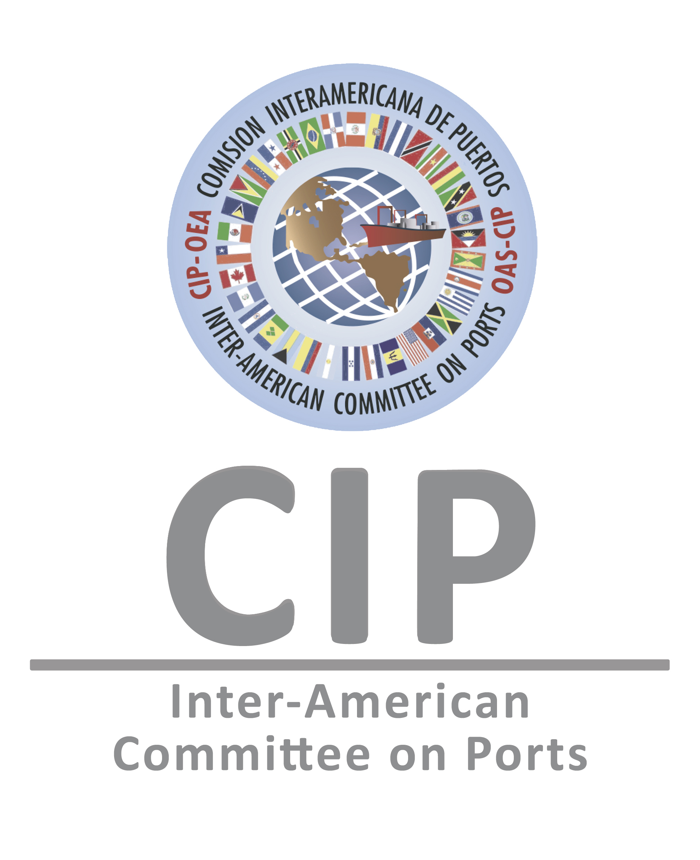
Application Form

GENERAL INSTITUTIONAL INFORMATION
Sector (chose one)   Public   Private | Type of Business (chose one)   National Port Authority / Port / Port Operator   Terminal   Commercial Shipping   Cruise Lines   Other Maritime or Port Industry ____________
Organization/Institution

City and Country

Full Name of Contact Person

Phone

E-mail address

INFORMATION ON THE PRACTICE
Category (please select only one)

Environmental Waste Management (please select one of the following sub-categories)
Commercial shipping,
Cruise Lines
Ports
❑ Green Port Operations in Ports and/or Terminals
❑ Public Outreach and Environmental Awareness
❑ Disaster Mitigation and Management in Ports and/or Terminals

City and Country where the practice presented is being implemented

Dates and Years of implementation (the practice must have been implemented for at least 1 year)

Please provide a brief problem diagnosis before implementation of the practice presented (max. 200 words)

Please provide a brief description of the solution proposed (max. 200 words)

General description of the practice presented (max. 600 words, including general indicators showing measurable impacts before and after the implementation).

Objectives (please mention only three specific objectives of the implemented practice)

Innovation Component (include use of technologies, new processes and/or “non-traditional” processes)

How does the practice contribute environmentally sustainable port and/or maritime operations (provide indicators)

Briefly explain how the practice raises awareness and/or increases knowledge in the corresponding area.

How does the practice include knowledge sharing, training and/or capacity building?

How does the practice promote inclusive strategic actions, including gender equality?

Please name any public and/or private alliances established while implementing the project.

Briefly describe the mechanisms implemented to obtain sustainability (e.g. capacity building, cost-efficiency, etc.).

Current situation after implementation. Provide any quantifiable indicators that measure the positive impact of the practice. (max. 500 words)

LIST OF DOCUMENTS REQUIRED TO BE ATTACHED TO THIS APPLICATION FORM
Executive Presentation of the Practice (Power Point, maximum 15 slides), with measurable indicators that demonstrate and verify the impact obtained through implementation;
Pictures and other Graphic Material that showcase the impact of the Practice presented;
Other Social, Economic, and/or Environmental indicators that demonstrate the impact, as well as the before and after of the practice/project/achievement presented;
Promotional Material, if applicable;

First and Last Name (Point of Contact) | Signature | Date

Please send this form and all required attachments to cip@oas.org, cc. mswoboda@oas.org. The Secretariat of the Inter-American Committee on Ports (S/CIP) can only consider complete applications. You will receive notification of receipt within three (3) business days. Submission deadline is January 15th, 2018.

NOTE: All personal data shared in this form will be used by the S/CIP and its partner institutions solely for the purpose of this award and in accordance with existing legislation on data protection.

You may enter in one or more of the categories above, but must submit a complete application for each category.

