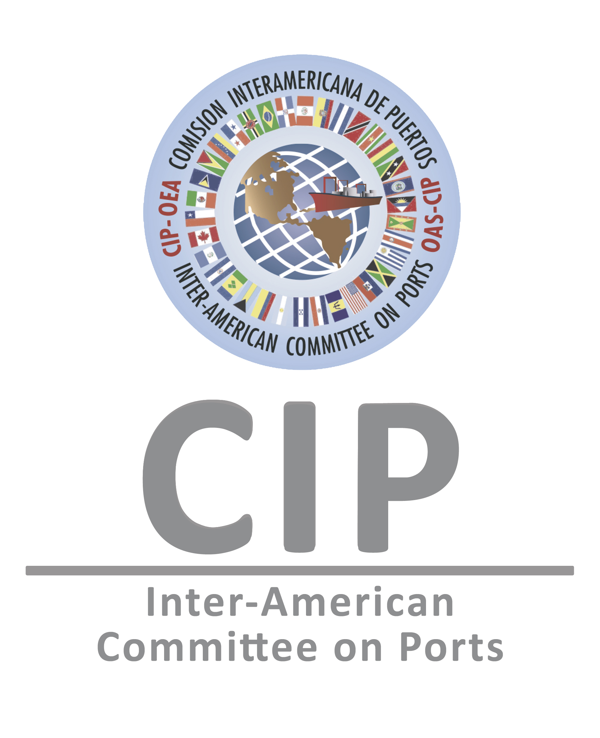
Application Form

GENERAL INSTITUTIONAL INFORMATION
Sector (chose one)   Public   Private | Type of Business (chose one)   National Port Authority / Port / Port Operator   Port   Port Operator   Terminal   Other Maritime or Port Industry ____________
Organization/Institution/Company

City and Country

Full Name of Contact Person

Phone

E-mail address

INFORMATION ON THE PRACTICE
Category (please select only one)

❑ Port-City Relations
❑ Disaster Management and Continuity of Operations in Ports and/or Terminals
❑ Digitalization, Automation, and Technological Transformation

City and Country where the practice presented is being implemented

Dates and Years of implementation (the practice must have been implemented for at least 1 year)

Please provide a brief problem diagnosis before implementation of the practice presented (max. 400 words)

Please provide a brief description of the solution proposed (max. 400 words)

General description of the practice presented (max. 700 words, including general indicators showing measurable impacts before and after the implementation)

Objectives (please mention only three specific objectives of the implemented practice)

Innovation component (include use of technologies, new processes and/or “non-traditional” approaches)

Briefly describe the mechanisms implemented to obtain sustainability of the practice implemented (e.g. capacity building, cost-efficiency, etc.).

Briefly explain how the practice raises awareness and/or increases knowledge in the corresponding area.

How does the practice include knowledge sharing, training and/or capacity building?

Please name any public and/or private alliances established while implementing the project.

How does the practice promote inclusive strategic actions, including gender equality?

Current situation after implementation. Provide any quantifiable indicators that measure the positive impact of the practice. (max. 700 words)

LIST OF DOCUMENTS REQUIRED TO BE ATTACHED TO THIS APPLICATION FORM
Executive Presentation of the Practice (Power Point, maximum 15 slides), with measurable indicators that demonstrate and verify the impact obtained through implementation;
Pictures and other Graphic Material that showcase the impact of the Practice presented, if applicable.
Other Social, Economic, and/or Environmental indicators that demonstrate the impact, as well as the before and after of the practice/project/achievement presented, if applicable.
Promotional Material, if applicable;
- Please note that the size of all documentation shall not exceed 10MB.

First and Last Name (Institutional Representative or Point of Contact) | Signature | Date

Please send this form and all required attachments to cip@oas.org, cc. Mona Swoboda, Program Manager, Secretariat of the Inter-American Committee on Ports (S/CIP), mswoboda@oas.org. The S/CIP can only consider complete and signed applications. You will receive notification of receipt within three (3) business days. Submission deadline is July 23rd, 2021, 11:59PM Eastern Standard Time. Late submissions cannot be considered.

NOTE: All personal data shared in this form will be used by the S/CIP and its partner institutions solely for the purpose of this award and in accordance with existing legislation on data protection.

You may enter in one or more of the categories above, but must submit a complete application for each category.

