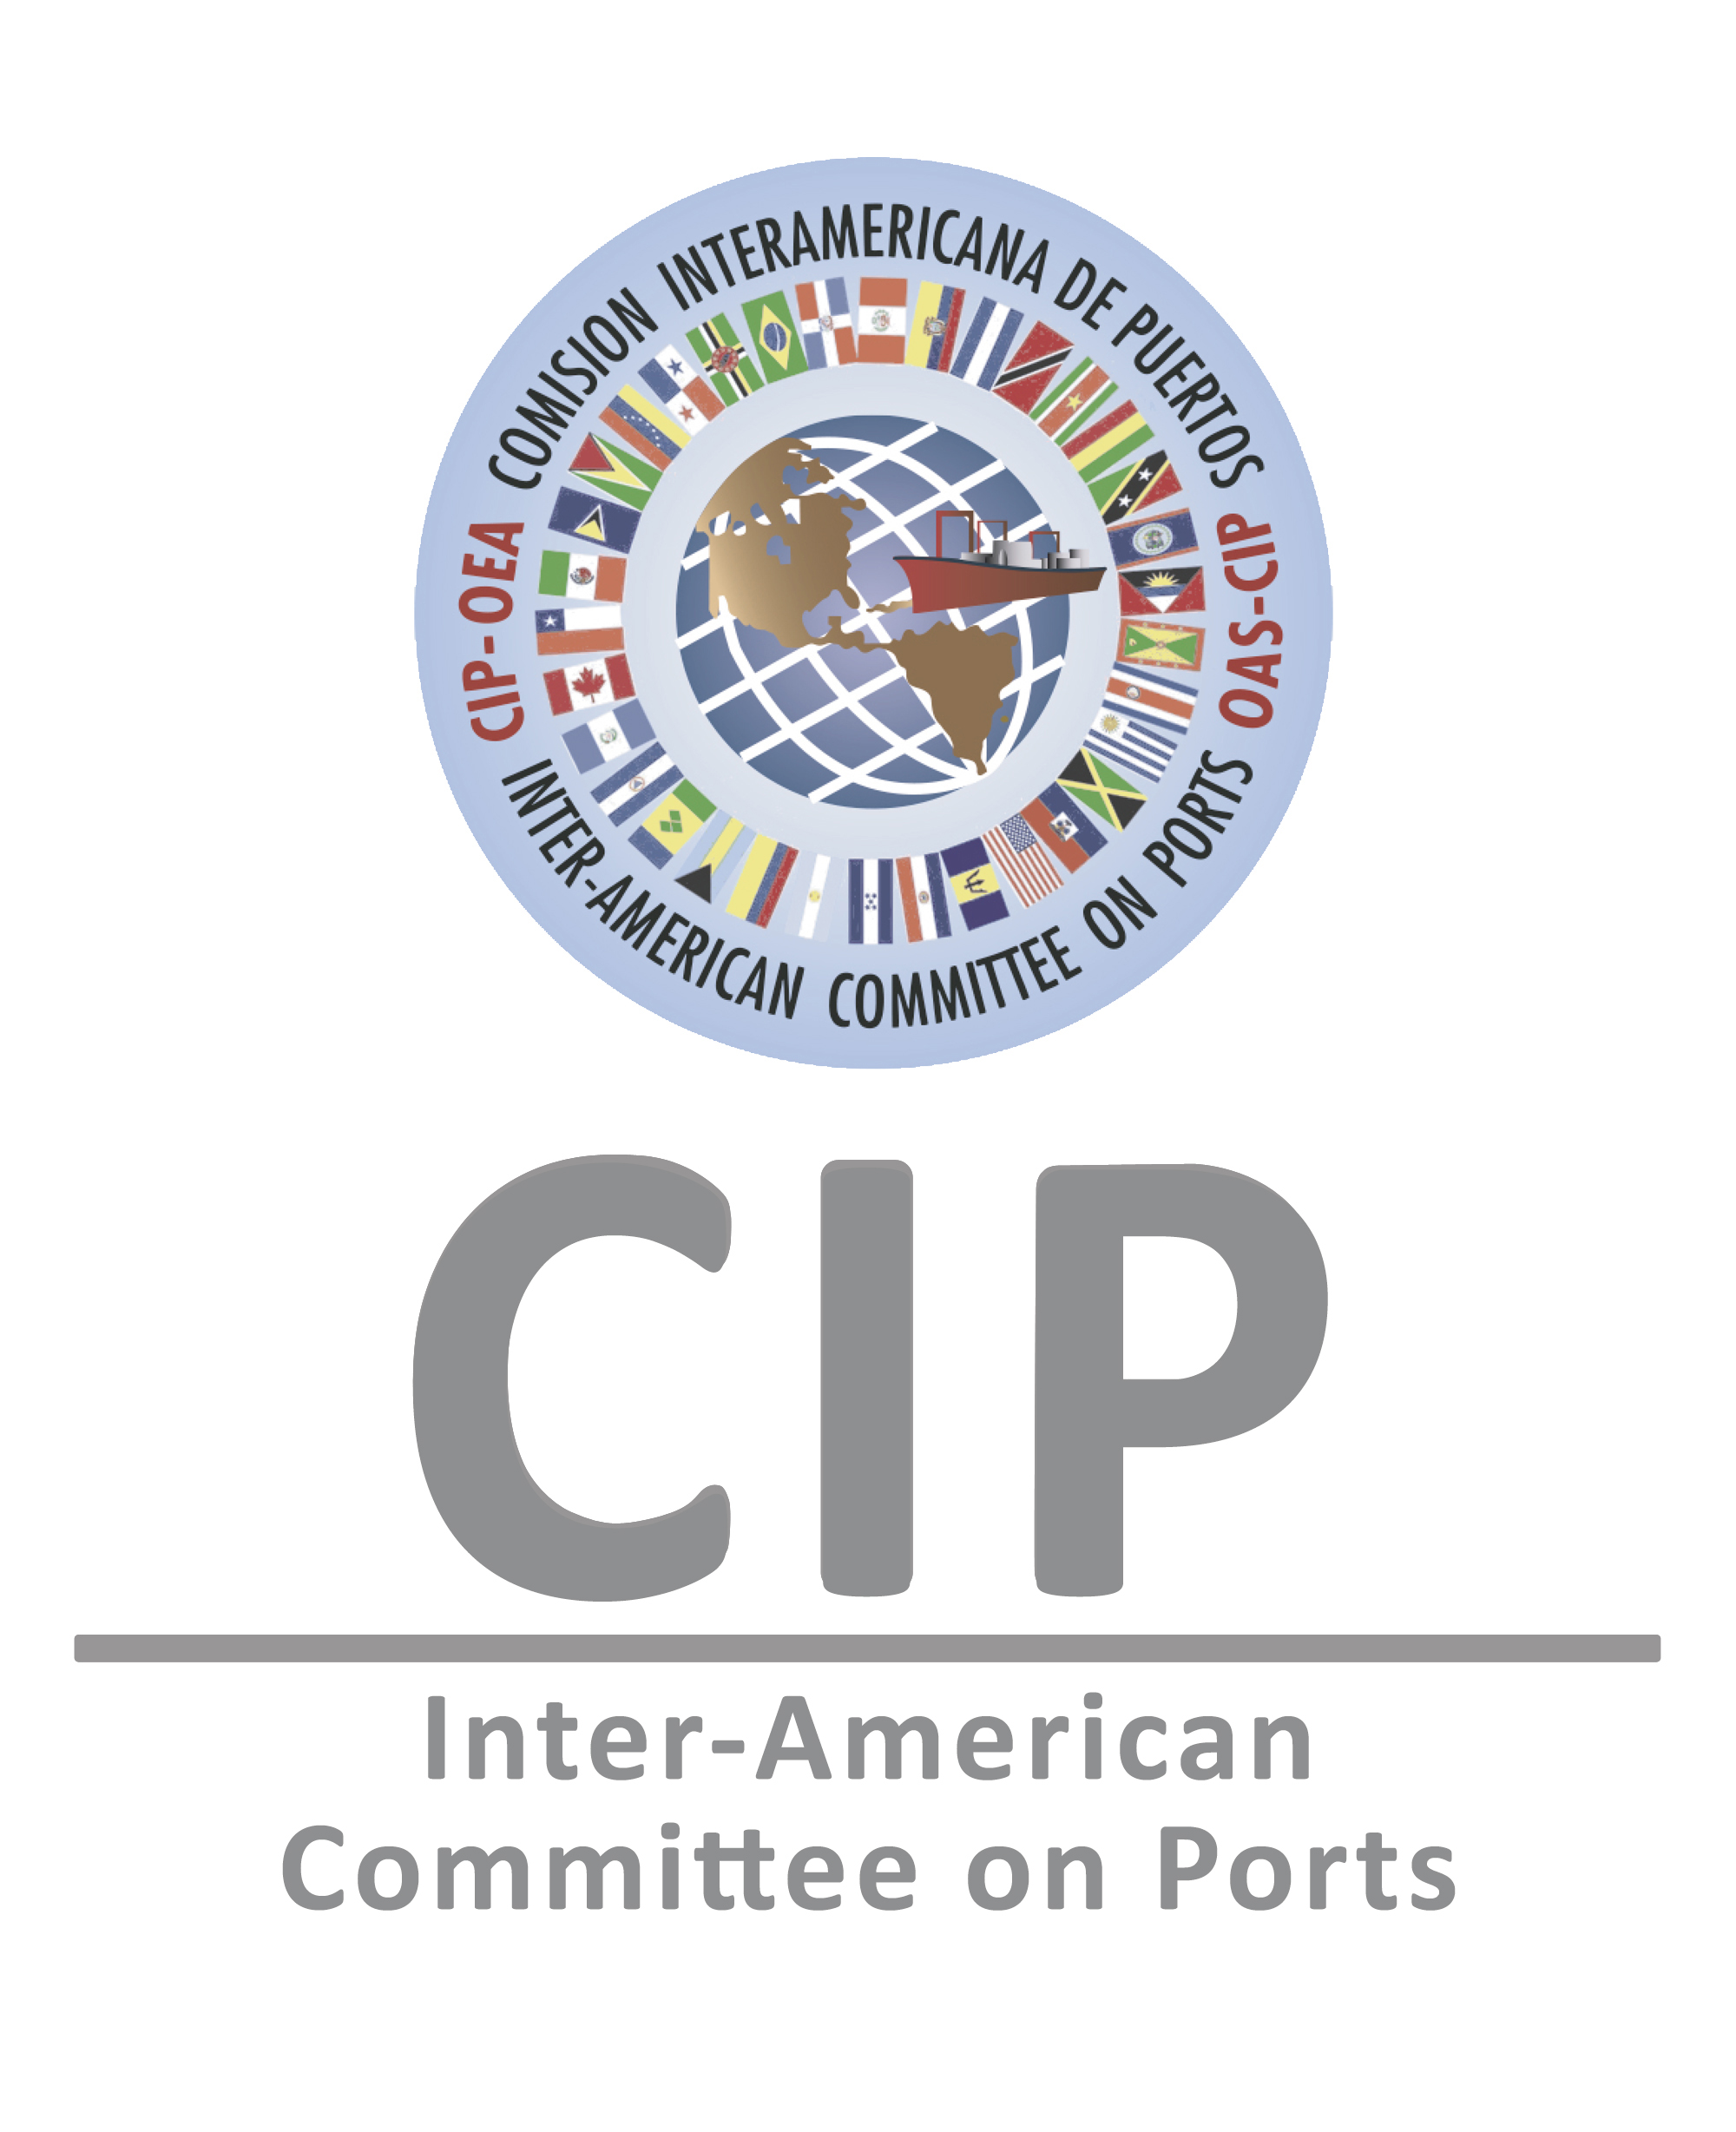
Application Form

GENERAL INSTITUTIONAL INFORMATION
Sector (chose one)   Public   Private | Type of Business (chose one)   National Port Authority   Port   Port Operator   Terminal   Other Maritime or Port Industry ____________
Organization/Institution/Company

City and Country

Full Name of Contact Person

Phone

E-mail address

INFORMATION ON THE PRACTICE
Category (please select only one)

❑ Competitive Digitalization
❑ Cybersecurity in Ports and/or Terminals
❑ Green Port Operations and Sustainable Management
❑ Empowerment and Equality

City and Country where the practice presented is being implemented

Dates and Years of implementation (the practice must have been implemented for at least 1 year)

Please provide a brief problem diagnosis before implementation of the practice presented (max. 400 words)

Please provide a brief description of the solution proposed (max. 400 words)

General description of the practice presented (max. 700 words, including general indicators showing measurable impacts before and after the implementation)

Objectives (please mention only three specific objectives of the implemented practice in bullet points)

Innovation component (include use of technologies, new processes and/or “non-traditional” approaches in bullet points)

Briefly describe the mechanisms implemented to obtain sustainability of the practice implemented (e.g. capacity building, cost-efficiency, etc., max. 300 words).

Briefly explain how the practice raises awareness and/or increases knowledge in the corresponding area (max. 300 words).

How does the practice include knowledge sharing, training and/or capacity building? (max. 300 words)

Please name any public and/or private alliances established while implementing the project.

How does the practice promote inclusive strategic actions, including gender equality? (max. 300 words)

Current situation after implementation. Provide any quantifiable indicators that measure the positive impact of the practice. (max. 700 words)

LIST OF DOCUMENTS REQUIRED TO BE ATTACHED TO THIS APPLICATION FORM
Executive Presentation of the Practice (Power Point, maximum 15 slides), with measurable indicators that demonstrate and verify the impact obtained through implementation;
Pictures and other Graphic Material that showcase the impact of the Practice presented, if applicable.
Other Social, Economic, and/or Environmental indicators that demonstrate the impact, as well as the before and after of the practice/project/achievement presented, if applicable.
Promotional Material, if applicable;
- Please note that the size of all documentation shall not exceed 10MB.

First and Last Name (Institutional Representative or Point of Contact) | Signature | Date

Please send this form and all required attachments to Mona Swoboda, CIP Program Manager, mswoboda@oas.org and cc. Mónica Blanco, CIP Project Coordinator, mblanco@oas.org. The CIP Secretariat can only consider complete and signed applications. You will receive notification of receipt within three (3) business days. Submission deadline is June 24, 2022, 11:59PM Eastern Standard Time. Late and incomplete submissions will not be considered.

NOTE: All personal data shared in this form will be used by the CIP Secretariat and its partner institutions solely for the purpose of this award and in accordance with existing legislation on data protection.

You may enter in one or more categories above but must submit a complete application for each category.

